Radiation and Environmental Surveys

**The Planetary Association for Clean Energy, Inc.**

**La Société planétaire pour l'assainissement de l'énergie, inc.**

100 Bronson Avenue / Suite 1001, OTTAWA, Ontario K1R 6G8

(613) 236-6265 fax: (613) 235-5876

[paceincnet@gmail.com](mailto:pacenet@canada.com) <http://pacenet.homestead.com>

### NGO in Special Consultative status with the Economic and Social Council of the United Nations (ECOSOC)

New York / Geneva / Vienna

________________________________________________________________________________

March 25, 2013

Donna L. McLarty

Town Clerk

**Town of Richmond Hill**

225 East Beaver Creek Road

RICHMOND HILL, Ontario

L4B 3P4 VOX: (905) 771-2529

FAX: (905) 771-2502

[clerks@richmondhill.ca](mailto:clerks@richmondhill.ca)

***Comments regarding the Bell Mobility Inc. submission for***

***Radio Communication and Broadcasting Antenna Systems Application***

***Town File D-25 – 12001***

***Of March 25, 2013***

Dear Donna L. McLarty,

The Planetary Association for Clean Energy, Inc. is a Canadian Learned Society (Society #109) that has developed an international, independent, collaborative network of advanced scientific thinking since 1975, under the leadership of the late Canadian scientist Senator, the Hon. Chesley W. Carter while he was chairperson of the Senate's Standing Committee on Health, Welfare and Science as well as member of the Senate Special Committee on Science Policy.

## Our network has been peer reviewing, extensively and on an international scale, and facilitating progress – as a priority - with regards to the question of electromagnetic fields since the earliest gatherings with the Senator. We continue to do so and consider it as one of the main scientific and technological concerns worldwide, which have been expressed at the United Nations Human Rights Council and through the *BioInitiative* declarations that have led to research international initiatives, criterion development and guidelines.

Herewith comments for the consideration of recommendations to be made by the **Committee of the Whole** with regards to the above item.

1. Intensity range of emissions at ground and the above-ground level spectrum-crowded “interconnect fabric” *including interaction between fixed and mobile emissions, including SMART meters, emergency services transmitters, airport and military facilities, Wi-Fi, NAN, Wireless LAN (3G – 4G), current and forecast into 2020*.

It is estimated that for certain residential, institutional, commercial (including two gas stations) near the application site, the outdoor intensity for the installation, under a variety of weather/soil conditions could extend from about **5.7 to 100.0** *micro*Watt/cm2 – at levels where a number of effects – whether material/physical or biological can manifest themselves, and well above the ***European Council*** limit of **1.0** *micro*Watt/cm2.

Indoors, for those residences and structures facing the site, though the general power levels tend to decrease very marginally – much less than 5% from the outside emissions (if there are no other “indoor” sources, such as SMART meters, routers, microwave ovens and wireless devices such cell-phones, pads, tablets, etc ). However, there can be cumulative effects, both non-thermal and thermal due to absorption (both resonant and non-resonant) and induction (inducing dipole/antenna effects in conductive elements such as re-bars, frames, and fixtures, as well as in trees and plants), ionic currents in structural materials (including bricks, mortar, soils) and semi-conductive rectification which can modify chemical nature of materials.

These, originally non-thermal effects, especially if they amplify into thermal and the weaker, athermal effects can result in fire, explosion and EMI (interference) hazards. Adverse incidents are becoming more common with SMART meters and devices such as garage openers, decoders, entertainment/player devices, rechargers, security systems, etc. Some of the concerns have come to the attention of the **Ontario Fire Marshall** (June 15, 2012) through a report presented by Armen Kassabian B.A.Sc. M.Sc. P. Eng. [armen.kassabian@ontario.ca](mailto:armen.kassabian@ontario.ca) Steven Silver B.Sc. P.Eng. of the Office of the Fire Marshal Fire Investigation Services, Midhurst, Ontario.

Below is a display indicating how radio-frequency and microwave emissions from the applicant site, as well as the continuously crowding “inter-connect fabric “of microwave technology in Richmond Hill can generate, over time, often cumulatively, into thermal and non-thermal effects not only on living systems but also on the physical environment. The analysis below was prepared on February 1973 by the **National Research Council of Canada** (Laboratory Technical Report KTR-CS-95, Control Systems Laboratory of the Division of Mechanical Engineering with **Queen’s University** researchers.

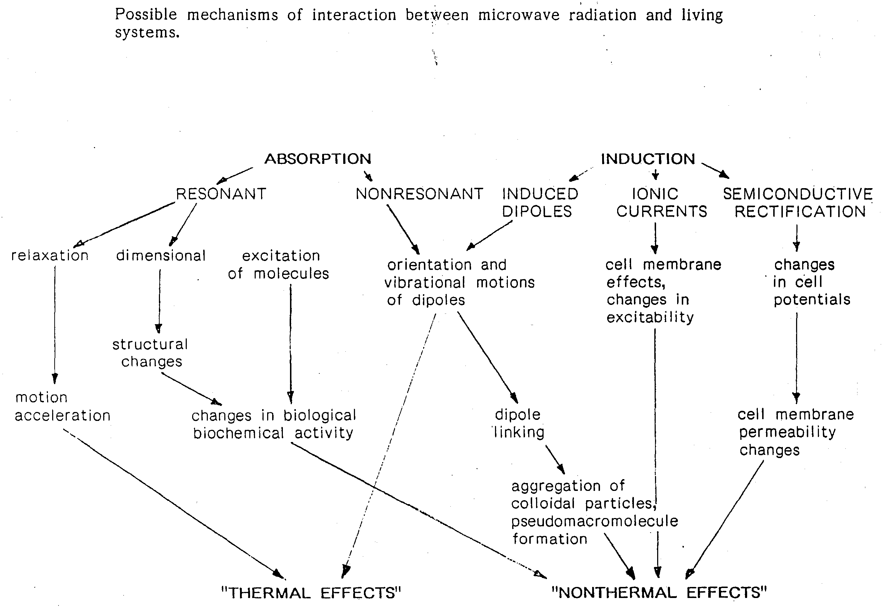

This intensity situation can be expected to expand in much more elevated power emissions due to “new architecture” most probably using the same structure and any current approval within a very short time frame, in view of Richmond Hill’s proximity to Toronto, and could increase probably another ten-fold within less than 10 years.

Current monitoring of similar development-type residential settings in Central Canada have shown that at about 1.5 to 2.5 meters above ground (head to extended arm level), the combination of other emitters, especially SMART meter data transfers and current wireless applications, the combined power density, even during periods of “low demand” ranges between **20 - 400** *micro*Watt/cm2, even while on-ground power levels can range as low as **0.004 / 0.2** *micro*Watt/cm2.

Below is a relatively “stale-dated” measurement for a central Ontario area antenna site (3 years old)

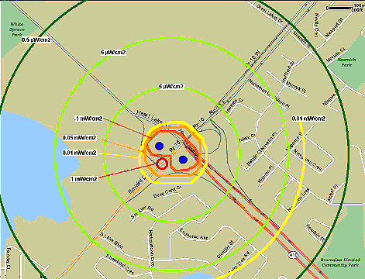

1. Health Canada Safety Code 6 specifically applies to federal employees and equipment only – on a ”good example” basis – and it does not address non-thermal effects.

The **Town of Richmond Hill** can evaluate whether it should consider alternative criterion and limitations in its planning of the crowded and emerging “interconnect fabric radio-frequency / microwave emissions regime in its territory. This has been done by the **City of Toronto Board of Health** (See Annex for the 2008 precursor). At least 14 Quebeccommunities are weighing this issue <http://www.dangersemo.com>, <http://www.cqlpe.ca/pdf/ResolutionDorval.pdf>

One of them, as an example, is **Ste Anne de Lacs** (Laurentians) has commissioned an engineering / planning analysis with consideration of the implications both the ***Health Canada Safety Code 6*** the ***European Council Resolution 1815*** (***2011)*** criterion for 1 *micro*Watt/cm2 in their municipal determinations of both operations of communication systems and protection of property and population. Oakville, Ontario has heard Health Canada witnesses <http://securet.oakville.ca/eams/pubmtgframe.aspx?meetid=1602&doctype=AGENDA>. Health Canada Safety Code 6 does not address non-thermal effects – whether on building materials, devices, structures, agriculture, or on human populations – and assumes only one (1) emitter at any time, not hundreds to tens of thousands of emission-points in a typical urban/semi-urban environment.

1. Implications of de-regulation and no federal enforcement of Code

Health Canada appears to have only two employees associated with ***Safety Code 6***, 1 for Eastern Canada, the other for Western Canada and does not even follow through on NON-COMPLIANCE of standards, of which we have reported since 1995, with no action taken. In the U.S. equivalent for Safety Code 6 for radio-frequency / microwave “limits”, the **FCC**, even though there have been safety violations in 23 States since 1996, no enforcement actions have taken for detailed site violations and only 1 wireless ***Notice of Violation***, and that in 2010. Even lower-powered sites can have mortality, especially during maintenance.

By way of example, in **Israel**, a government monitoring system has found so many violations daily in its small territory, that the fines alone pay for the software & staffing involved and create considerable public treasury revenues. It is generally understood that the applicants are uninsured. Most likely, there will be more fixed “de-regulated” and regulated transmitters to accommodate “spectrum crowding” issues, probably recycling existing fixtures and sites.

1. Liability and disadvantages: Town of Richmond Hill

This situation may mean that **Town of Richmond Hill** could become vulnerable to liabilities associated with fires and explosions, structural damage, equipment failure, especially when there is a lack of accountability and insurance coverage. (See attached document from the ***American Trial Lawyer***). Devices such as SMART meters, which will interact with the site applicant, are not certified by product-safety UL, they are subject to hacking, raising privacy issues from the community. Even the **United States** **Government Accountability Office** (**GAO**) has asked the **FCC** (Health ***Canada Safety Code 6*** equivalent) to re-evaluate the standard.

The **Town of Richmond Hill** should consider evaluating:

* about 30% decrease in taxable property value in adjacent property / wards
* acceleration of infrastructure deterioration (corrosion of public and private facilities)
* adverse health effects, especially growing number of environmental sensitivity
* continuous pressure by wireless operators to increase their facility power and spectra
* increasing budget for maintenance of “status quo” in view of increasing radiation
* liability to legal and like actions
* no support from federal, and possibly provincial government, in related adverse situation
* risks of fire / explosion / electromagnetic interference issues

We hope that this communication will help in your deliberations.

Yours sincerely,

Dr. A. Michrowski

President

ANNEX 1



ANNEX 2

### ****City of Toronto Medical Officer of Health Report****

(May 29, 2008) Report from the Medical Officer of Health / <http://www.toronto.ca/health/boh_reports.htm> **(Summary)**  
  
The Board of Health and Toronto City Council recently endorsed a Prudent Avoidance Policy that will help ensure that public exposure to radiofrequencies (RFs) from cell phone towers is 100 times below the current Health Canada exposure standard known as Safety Code 6. This policy does not address public exposure to RFs from the use of telecommunication devices such as cell phones. RF exposure from using a cell phone can be considerably higher than environmental exposure to RFs from local cell phone towers or antennas. Cell phone use has risen consistently in the last decade in Canada. In particular, the number of children who use cell phones has increased greatly. This report responds to the Board of Health’s request for further information on the use of cell phones by children and youth and their consequent exposure to RF energy.   
  
The 2007 Toronto Public Health (TPH) report titled “Update and Review of Research on Radiofrequencies: Implications for a Prudent Avoidance Policy in Toronto” summarized research about RF exposure and potential health impacts in people. Considerable research has been done to explore the health impacts from cell phone use in adults. There are gaps in knowledge however, regarding exposure and health impacts in children. The research that is available suggests that children are likely more vulnerable than adults.   
  
Many international reports and scientific experts in the field view the limitations and uncertainty of current research as warranting precautionary recommendations around children’s use of cell phones. There are currently no specific Canadian recommendations with regard to cell phone use by children. Some jurisdictions in Europe recommend that children decrease their exposure to RF by strictly limiting their use of cellular phones and some have strongly recommended that use be avoided completely. TPH has broadened its precautionary messages and advice on cell phone use. The focus is on messages for parents and teens to limit use of cell phones by children where possible.   
  
**Background Information**  
[Cell Phone Use by Children and Youth - Staff Report](http://www.toronto.ca/legdocs/mmis/2008/hl/bgrd/backgroundfile-13559.pdf) (PDF file size 40KB)

|  |  |
| --- | --- |
| **Progress Report on a City of Toronto Environmental Reporting and Disclosure Program** | |
|  |

|  |
| --- |
| **Background Information** |
| Progress Report on a City of Toronto Environmental Reporting and Disclosure Program - Staff Report  (<http://www.toronto.ca/legdocs/mmis/2008/hl/bgrd/backgroundfile-13981.pdf>)   A Proposed Environmental Reporting and Disclosure Program for the City of Toronto - Technical Report  (<http://www.toronto.ca/legdocs/mmis/2008/hl/bgrd/backgroundfile-13982.pdf>) |

<http://www.toronto.ca/legdocs/mmis/2008/hl/agendas/2008-07-03-hl16-ai.htm>

|  |
| --- |
| **Reducing Electromagnetic Field Exposure from Hydro Corridors** |

|  |
| --- |
|  |

|  |
| --- |
| **Background Information** |
| Reducing Electromagnetic Field Exposure from Hydro Corridors - Staff Report  (<http://www.toronto.ca/legdocs/mmis/2008/hl/bgrd/backgroundfile-13980.pdf>) |